C2835 – Hazelbush Drain Bridge, Foggathorpe
Project Briefing Note 1
August 2026
Introduction

Hazelbush Drain Bridge is a brick arch bridge located on Bell Lane, Foggathorpe (USRN 45900258). The bridge carries the local highway over a watercourse maintained by the Ouse and Humber Internal Drainage Board (IDB). Recent inspections have identified structural defects that require further investigation and the development of a long-term solution.

Location
- Easting: 475367
- Northing: 436806
- What3Words: ///jungle.preheated.trails

Current Condition
The following issues have been identified during general inspections undertaken by the Highway Structures Team.
- Large progressive cracking between the headwalls and brick arch
- Carriageway displacement and associated cracking
- Differential settlement of the foundations
- Poor underlying ground conditions
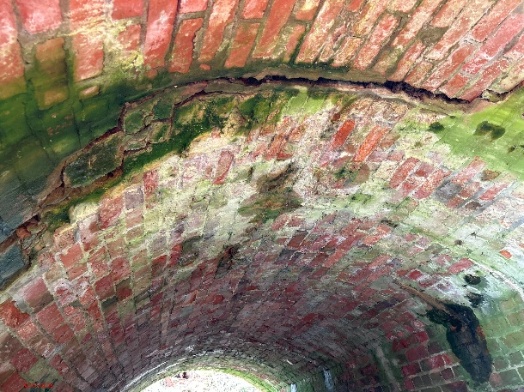
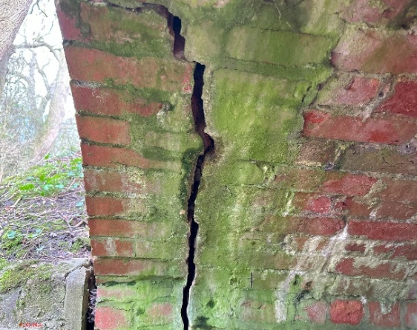

Headwall and arch separation cracking at both ends of the structure
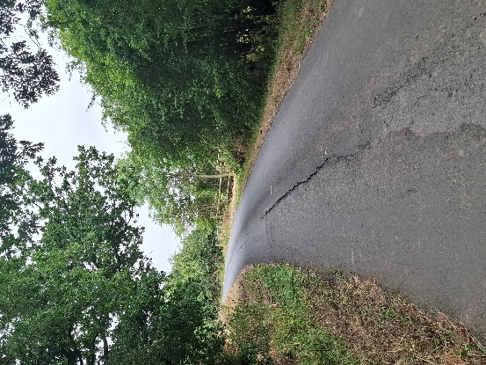
Settlement in carriageway
Scheme Design
A range of potential options are currently being considered, including:

- Full demolition of the existing brick arch structure, replaced with pre-cast concrete box unit. Installation of a bagged retaining wall on the east of the structure to stabilise road.

- Infill of damaged structure and connection of new piped ditch line on west side to link with crossing further downstream. This would also create a retaining wall for the road.

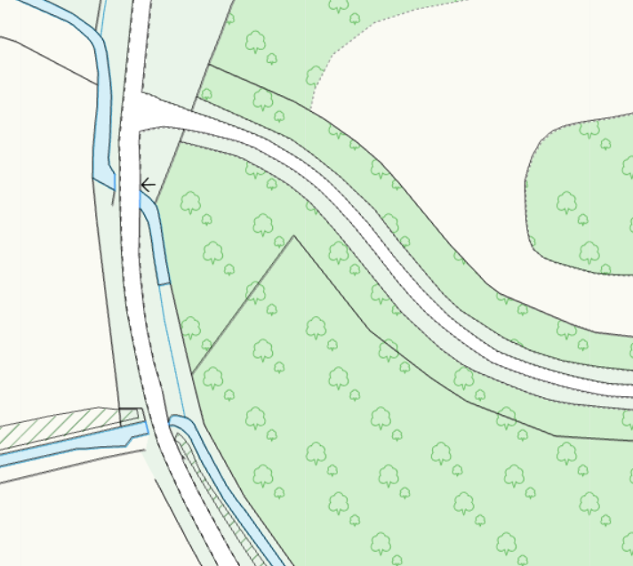

Key Design Considerations

- Any proposed solution will be designed to achieve a minimum design life of 120 years.
- Design approval will be required from the Ouse and Humber Internal Drainage Board (IDB).
- Field and Landowners consultation
- Ecological requirements and flood risk considerations will be incorporated into the design and construction methodology.
- The watercourse and associated approvals fall under the responsibility of the IDB.
- The area is predominantly agricultural and access requirements for farm traffic will be considered throughout the project.
- The bridge is located on a school bus route. Liaison has already taken place with the Council's Transport Team regarding diversion arrangements during future road closure periods.
Programming
The current programme is as follows:

- Site investigation works: August 2026.
- Detailed design and approvals: Late 2026.
- Main construction works: Early 2027.
- Anticipated completion: April 2027

The programme remains subject to the outcome of the site investigations, design development and the receipt of all necessary approvals.

Procurement

The works are being procured through the YORcivil3 Framework using the Direct Selection process. This enables Early Contractor Involvement (ECI), allowing investigations, design development and construction planning to progress efficiently whilst maintaining compliance with procurement regulations.
This approach is expected to support programme certainty, effective risk management and greater cost control as the preferred solution is developed.

Temporary Traffic Management
A temporary road closure will be required.
All traffic will be diverted via Station Road, A163, B1228, Wood Lane, Tottering Lane returning to Bell Lane.
Advance warning signs will be erected prior to the works to notify road users of the closure and diversion route.
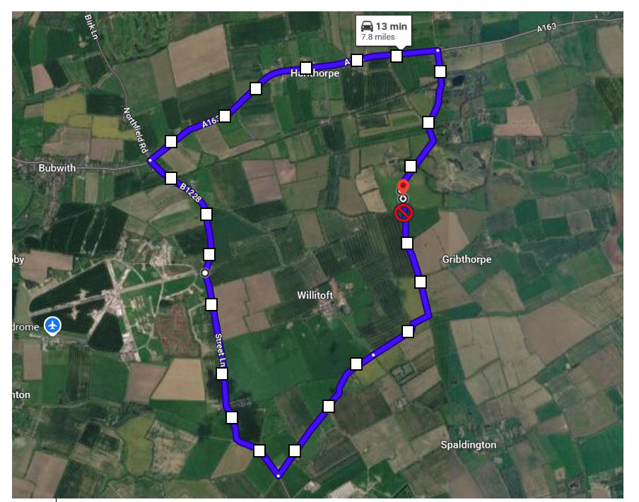
Road Closure
Diversion Route
Consultation and Communication – Site Investigation Works

- Project brief issued to Portfolio Holders and local ward members – August 2026
- Notify affected and nearby Parish Councils – August 2026
- Liaison with landowners and the Internal Drainage Board (IDB) – August 2026
- Letter drop to residents and businesses – August 2026
- Advance notification signage erected on site prior to the commencement of works and associated closure periods – August 2026

Consultation and Communication – Main Replacement Works

- Project brief issued to Portfolio Holders and local ward members – December 2026
- Notify affected and nearby Parish Councils – December 2026
- Liaison with landowners and the Internal Drainage Board (IDB) – October/November 2026
- Letter drop to local residents and businesses – December 2026
- Advance notification signage erected on site prior to the commencement of works and associated closure periods – Early January 2027

Contact details
If you have any comments or require any further information regarding this scheme, please contact:
Kirk Lister
Senior Engineer
Highway Structures
email: kirk.lister@eastriding.gov.uk

Laura Dixon
Construction Assistant
Highway Structures
Email: laura.dixon@eastriding.gov.uk

Phil Smith
Principal Engineer
Highway Structures
email: phil.smith@eastriding.gov.uk

James Sissons
Acting Head of Civil Engineering Services
email: james.sissons@eastriding.gov.uk

